RUBIKS CUBE
The Rubik’s Cube was invented in 1974 by Ernõ Rubik, a Hungarian architecture professor. Rubik later used the Cube as a learning exercise to teach his students about 3-dimensional spaces. Little did he know his “Magic Cube” (as he originally named it) would become one of world’s most famous puzzles of all time!
Rubik’s cube is a fun toy to pay with.
And there are lots of algorithms to solve it.
The most easy and popular one is F2L.
This is a Rubik’s cube.
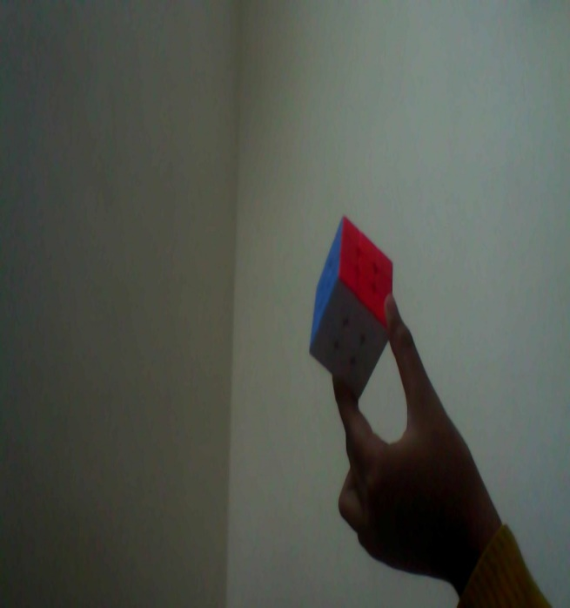

8:30

Learn F2L in 6 minutes (Full Intuitive F2L Tutorial)

A link to solve a Rubik’s cube..
There are also companies that makes Rubik’s cubes like GAN, CUBELELO and RUBIKS.
People who solve Rubik’s cubes are called CUBERS or SPEED CUBERS.
People also solve cubes very fast like 19 seconds and even 3.47 second (world record)
the Rubik’s cube also comes in magnetic versions like` cubelelo 3x3 magnetic drift’.
This is a GAN11M pro magnetic.
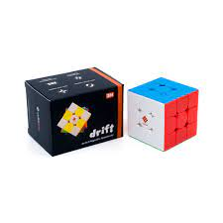This is cubelelo 3x3 drift magnetic.
CUBERS COMPETITITON
There are cubers competitions every year .people go there to show there cubing skills and how much time they take to solve it.

OUTRO
we learned many things about Rubik’s cubes.
To get a cube here are some options that I chose the best.
1. CUBELELO 3X3 DRIFT (MAGNATIC)
2.GAN 11M PRO (MAGNATIC)
3. Cyclone Boys Metallic 3x3 (Magnetic)
The founder of Rubik’s cube ` Ernő Rubik

